BIT 4107 – Mobile Application Development
ENHANCED PROFESSIONAL STUDENT LOGBOOK
Student Name: FAITH MUTUKU
Admission Number: BIT/2024/55704
School/Faculty: COMPUTING & INFORMATICS
Programme: BSCIT
Academic Year: 3
Semester: 2
Lecturer: MICHEAL NYORO
Phone Number: 0746114961

Instructions
This logbook is used to document weekly learning activities, practical exercises, skills acquired, challenges encountered, solutions applied, and reflections. Students should complete all sections every week.
Each week to follow remarks in week 1 section.

Autogenerated Table of content

Week 1: Introduction to Mobile Application Development

Practical Activities Undertaken
only screenshots needed and labeling
Screenshots/Evidence Attached (Yes/No)

Tools/Software Used
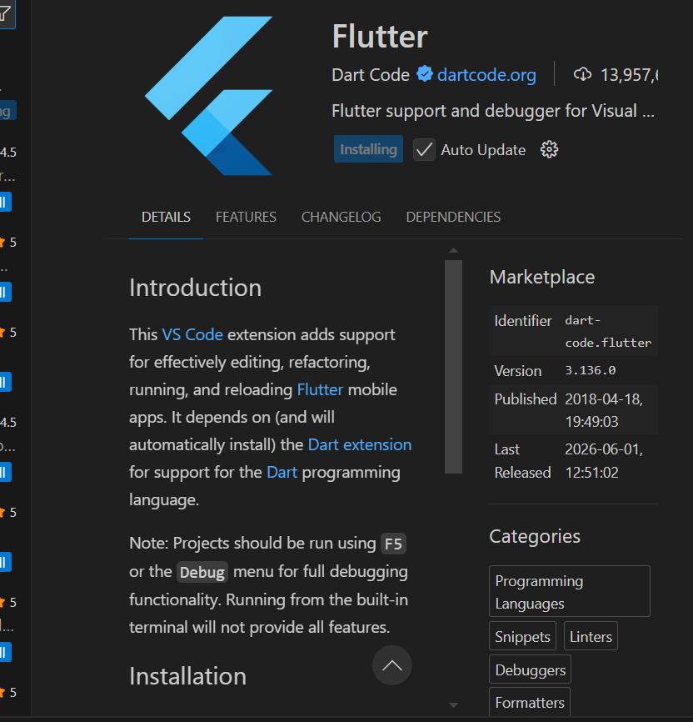
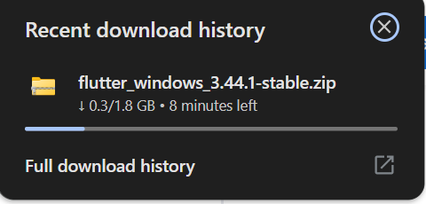
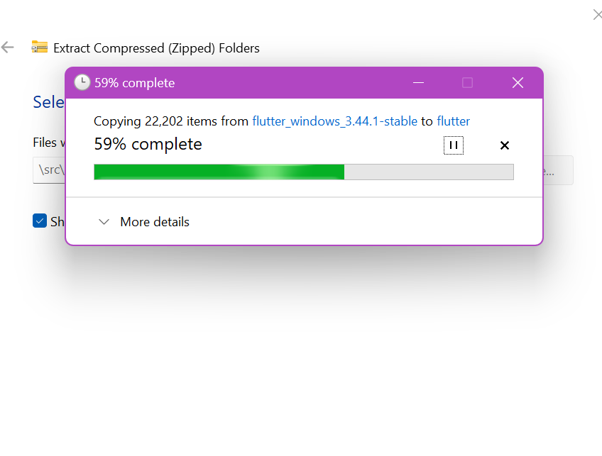
Personal Reflection (not more than 50 words)
Learned how to set up Flutter, VS Code, and Android emulator. Gained understanding of project initialization and environment configuration. Faced setup issues but resolved them through debugging and guidance.

Week 2: Mobile Development Environment
Same as week 1

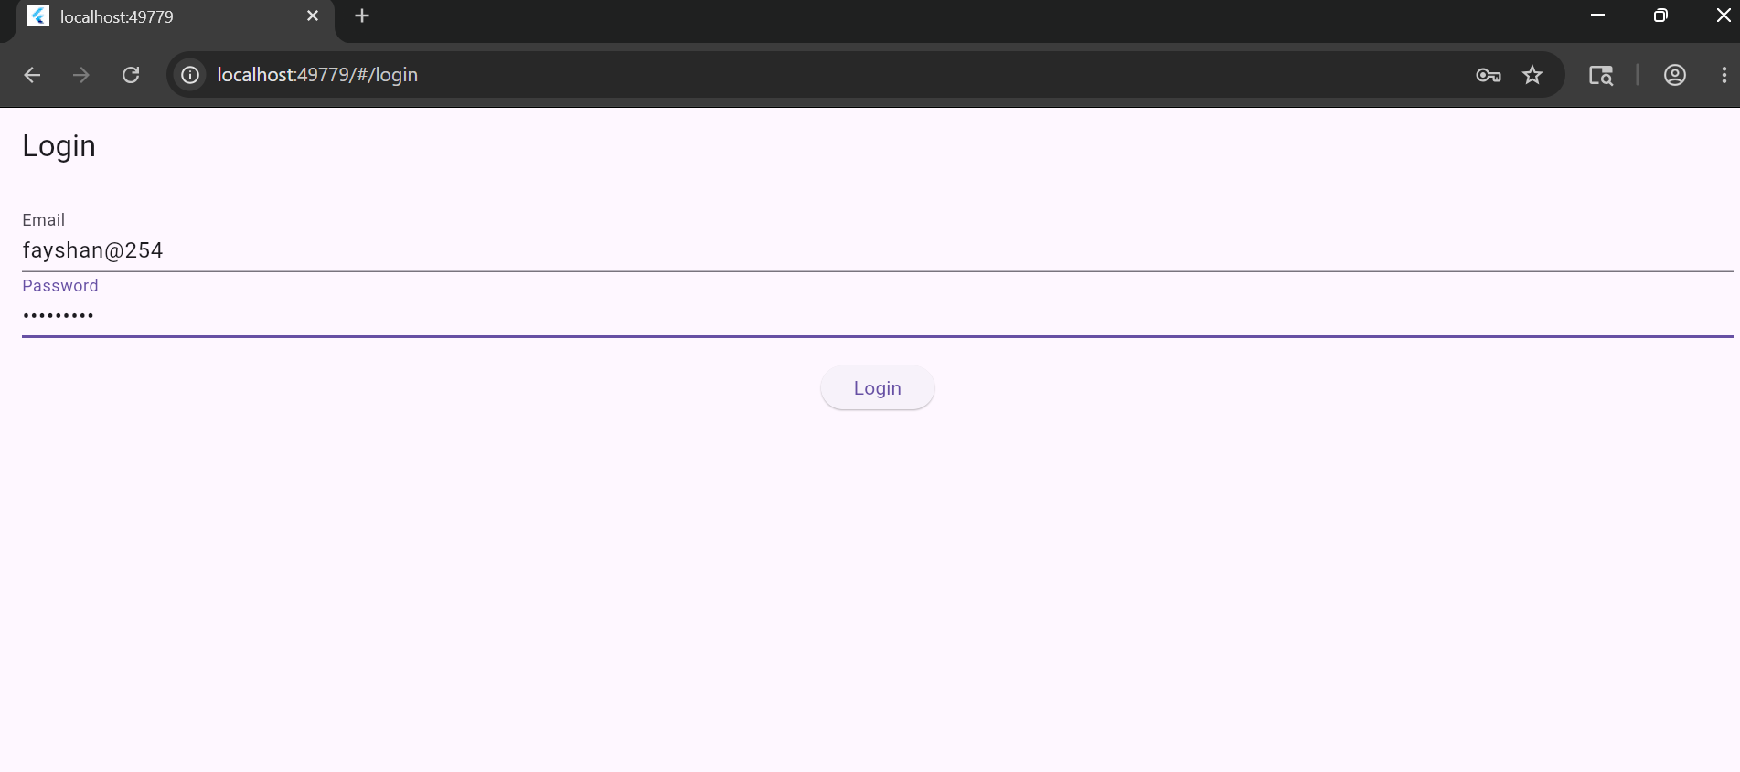
Login screen

role screen

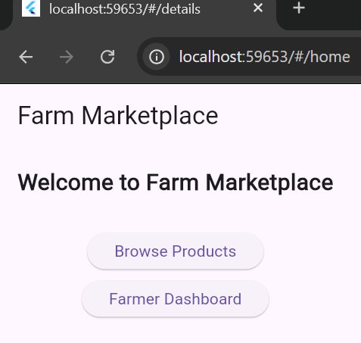
Product screen
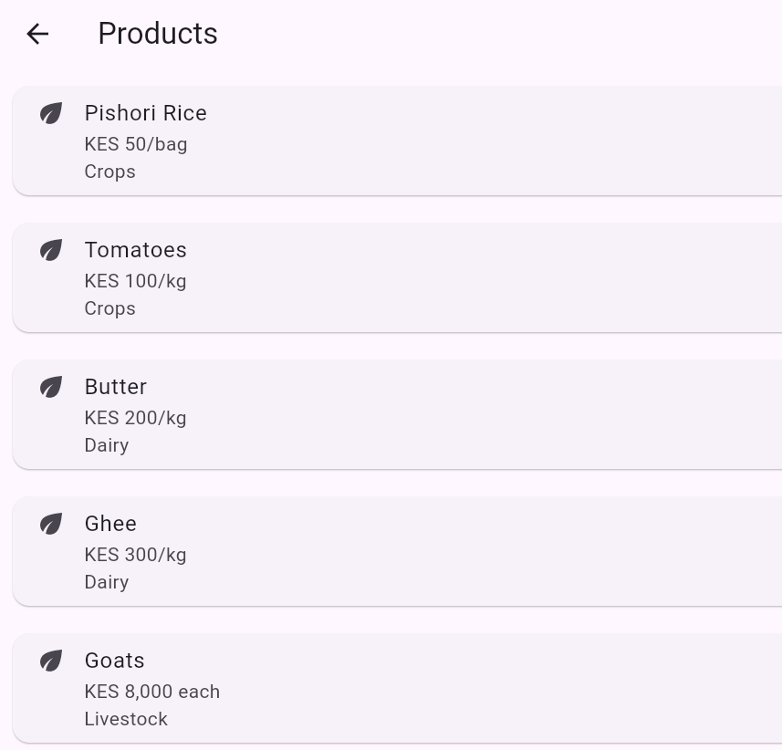
Farmer Dashboard

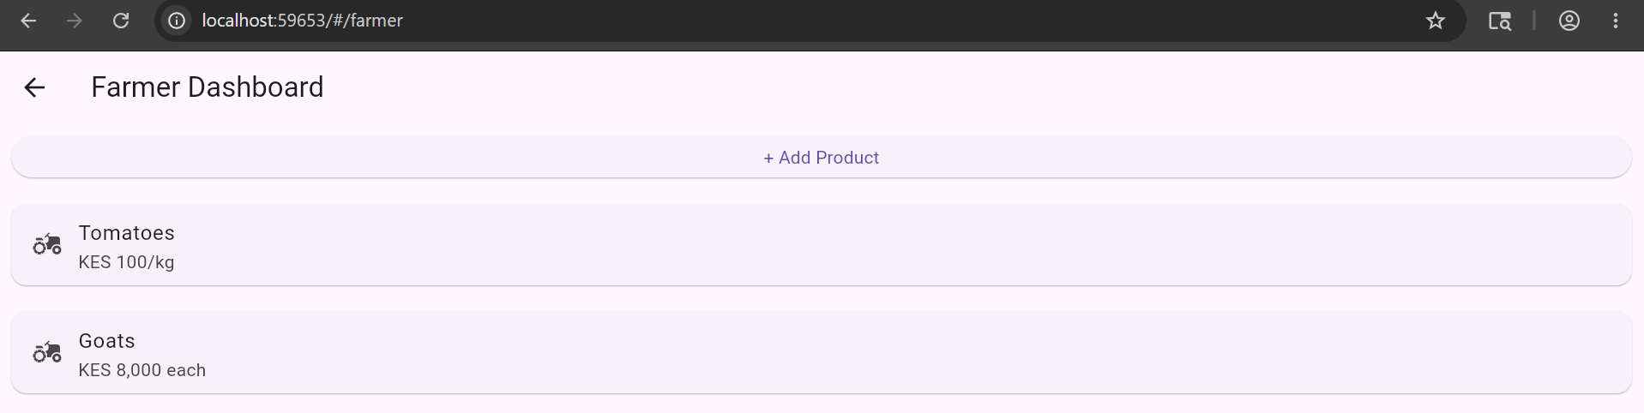

PERSONAL REFLECTION
Learned Flutter UI development and navigation between multiple screens. Improved understanding of widgets and layout design while building the login, role, and dashboard screens.

Week 3: User Interface Design
LOGIN SCREEN
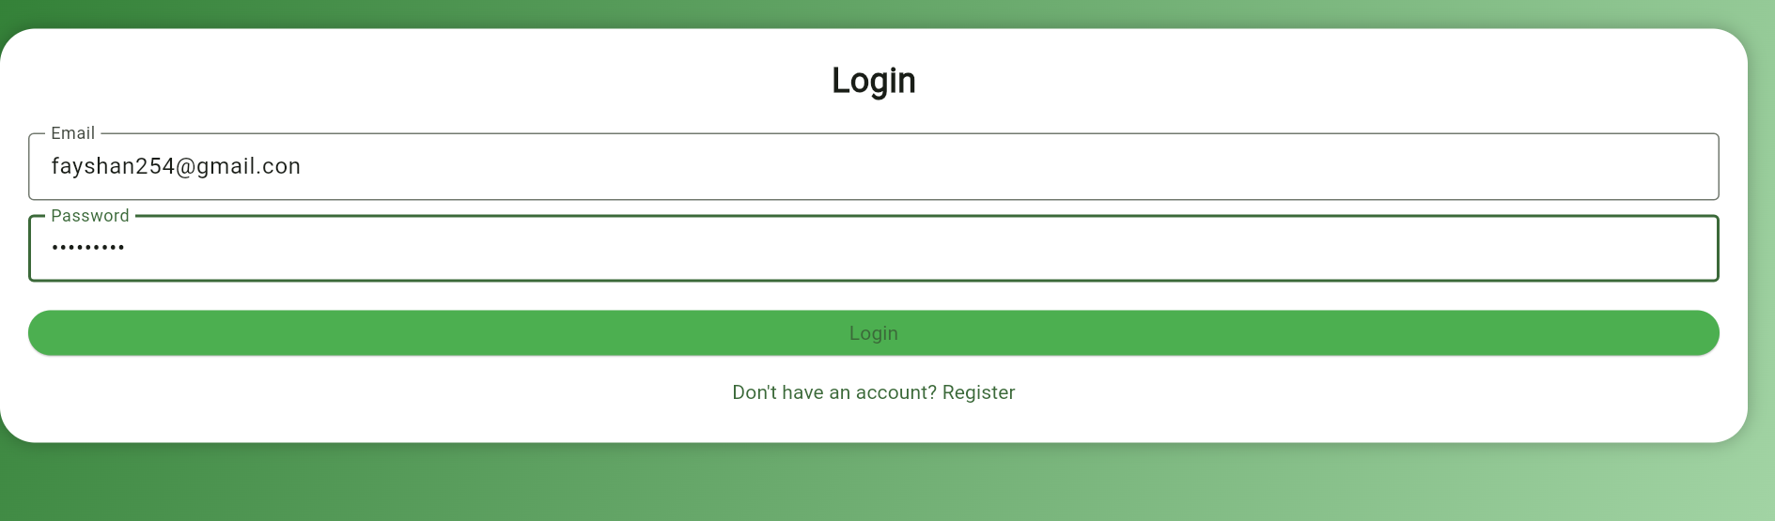
REGISTATION SCREEN
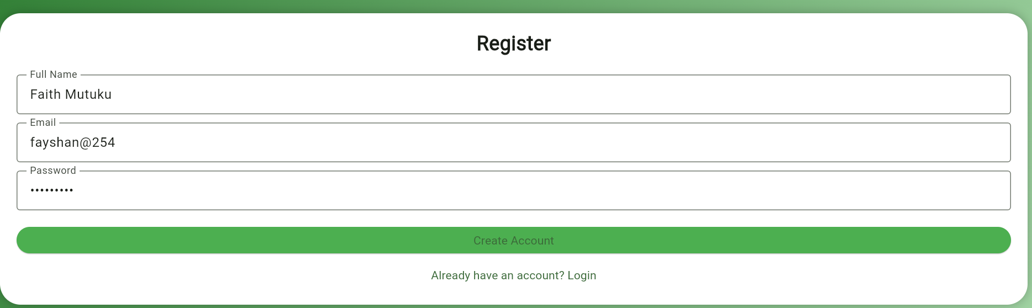
ROLE SCREEN
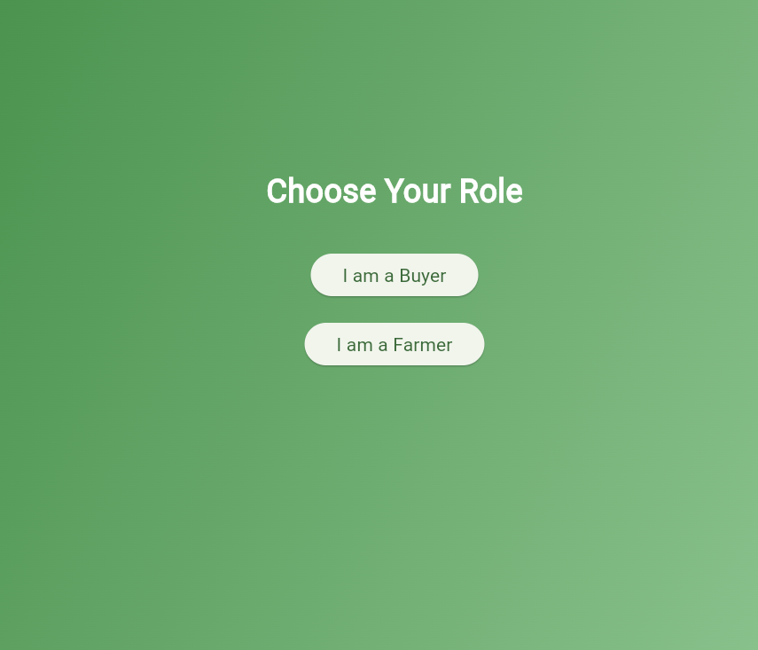
CATEGORIES SCREEN
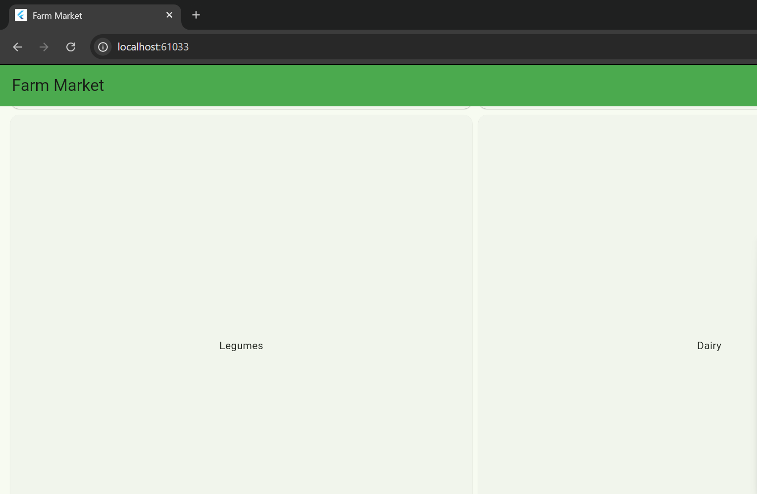
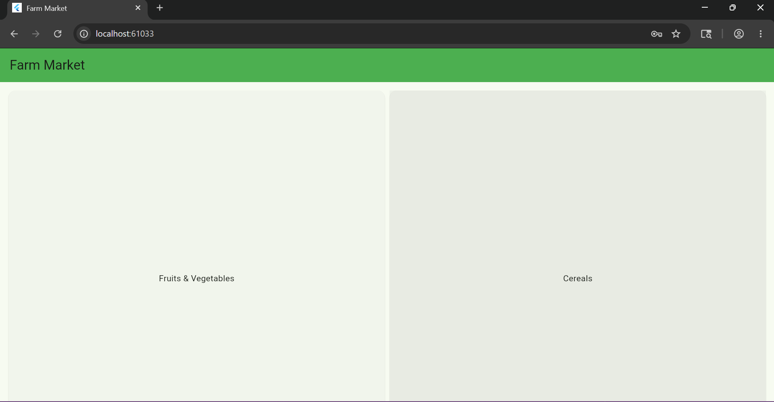

Product screen

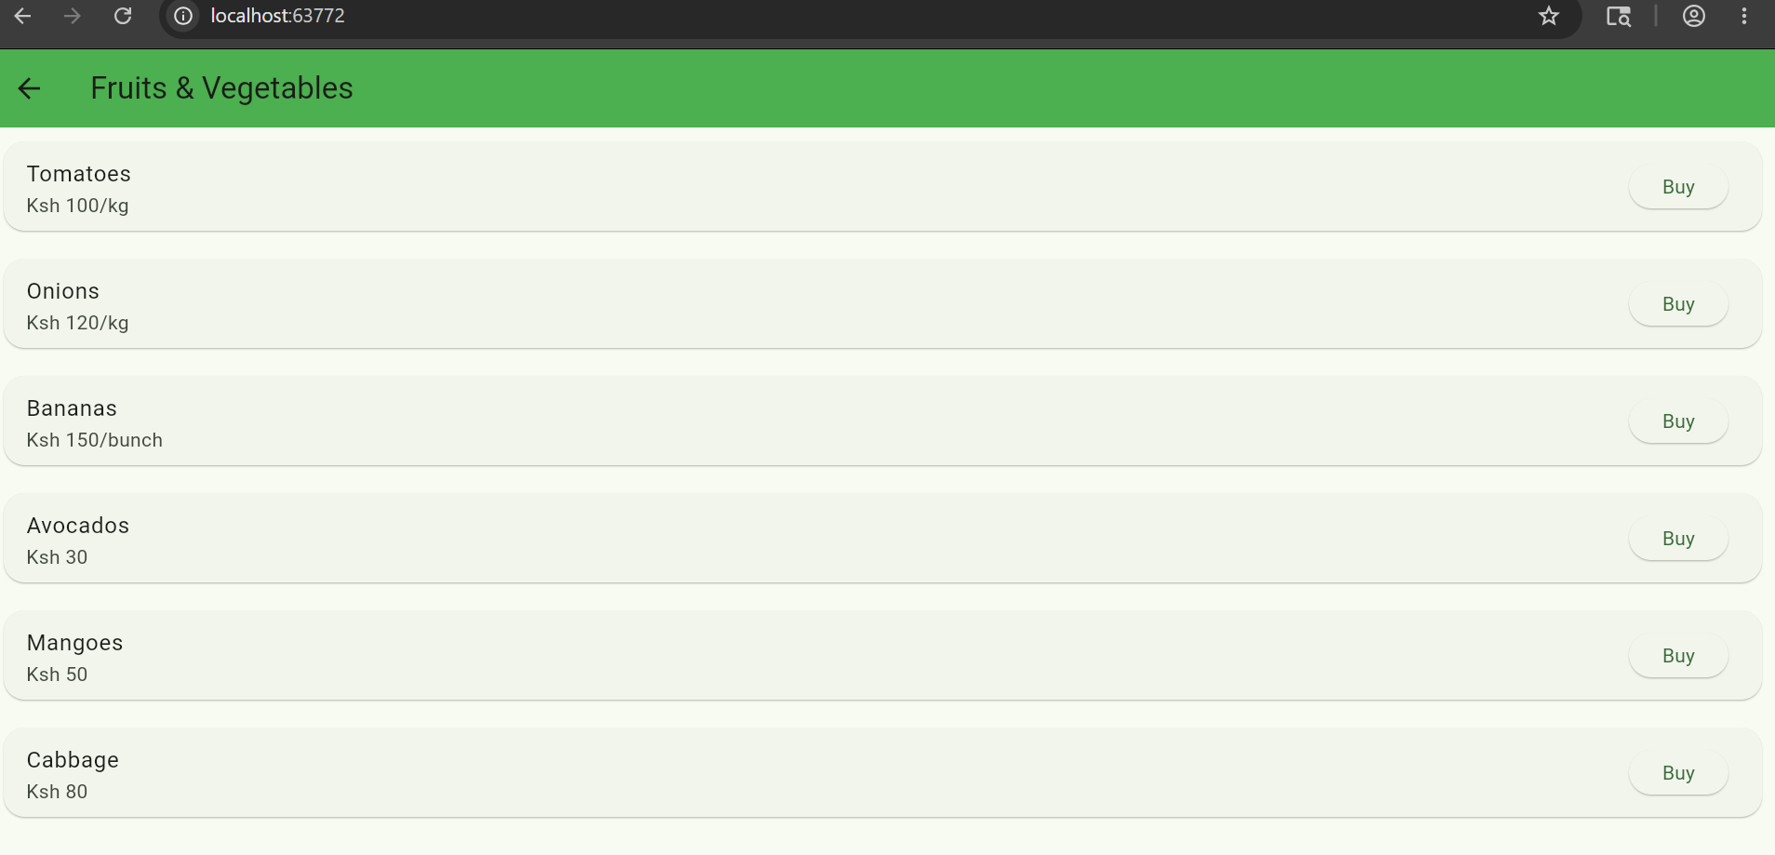

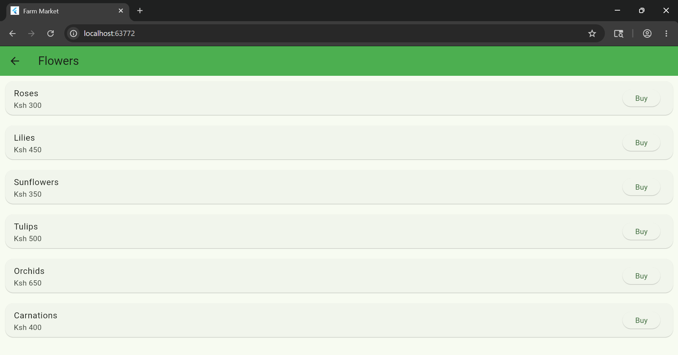

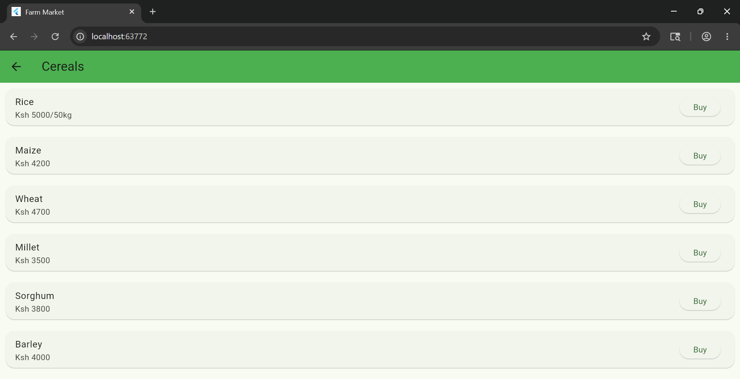

PERSONAL REFLECTION
Gained experience in UI/UX design using Figma. Learned how to create wireframes and translate design prototypes into Flutter screens for better user experience.

Week 4: Event Handling and User Interaction
ADD/UPDATE

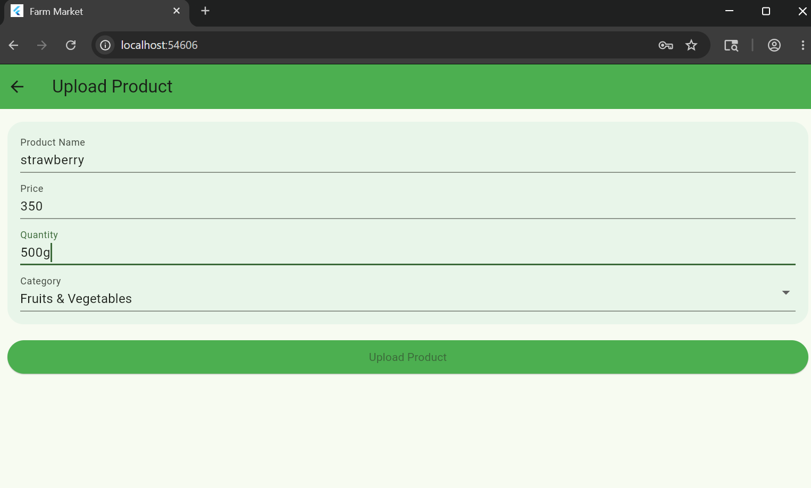
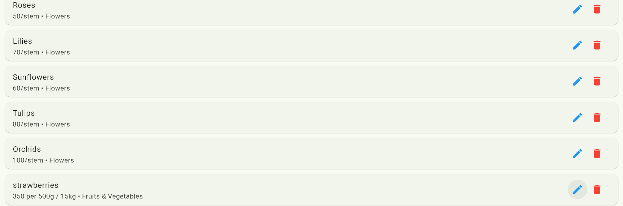
SEARCH
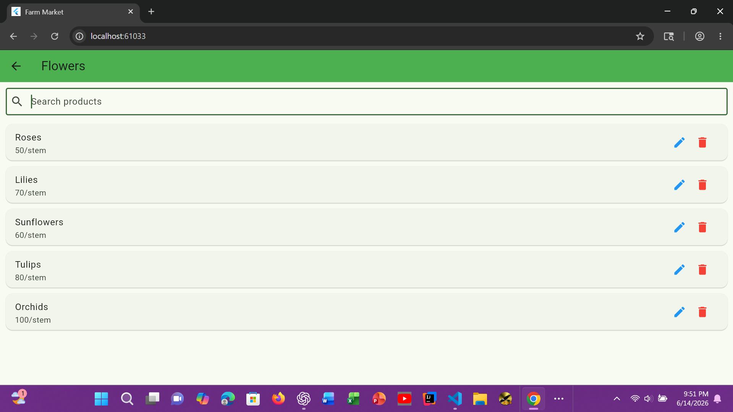
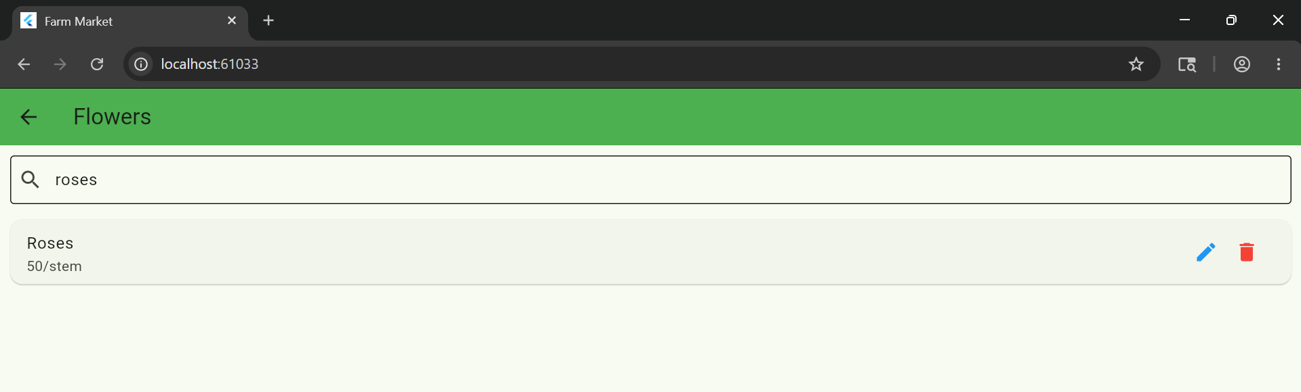

DELETE
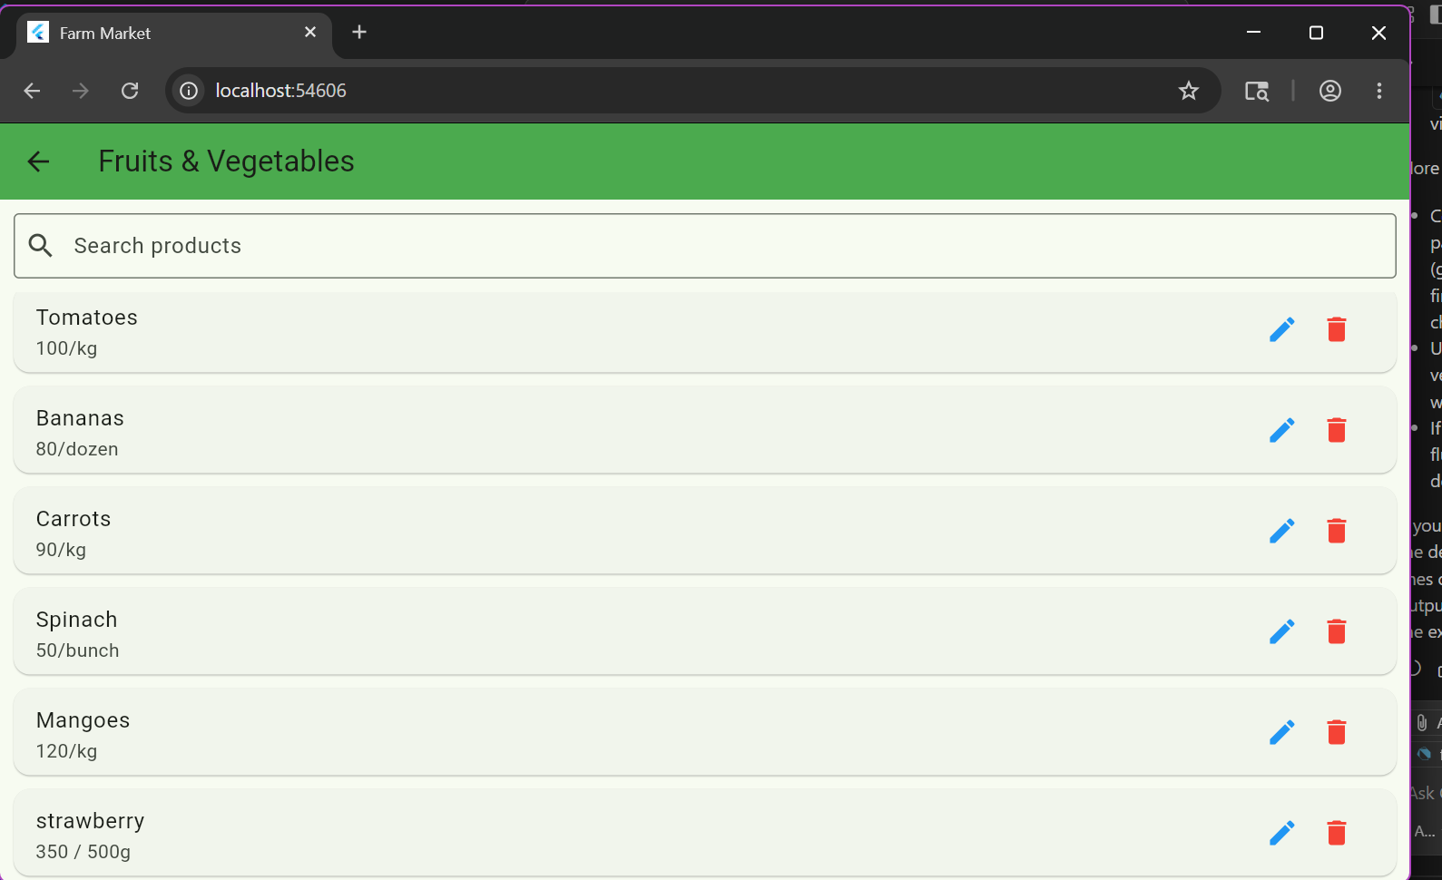

PERSONAL REFLECTION
Developed CRUD functionality for products. Learned how to add, update, delete, and search data using a local data structure, improving logic and state handling skills.

Week 5:Data Management



Personal reflection
Was able to add data smoothly

Week 6: Networking and APIs

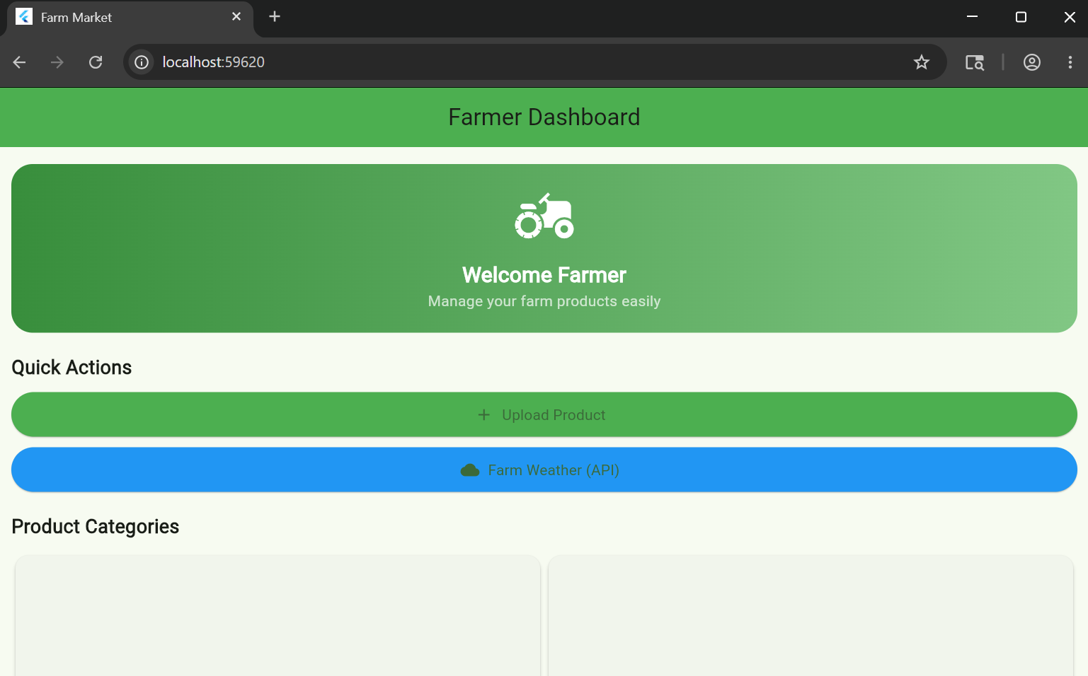

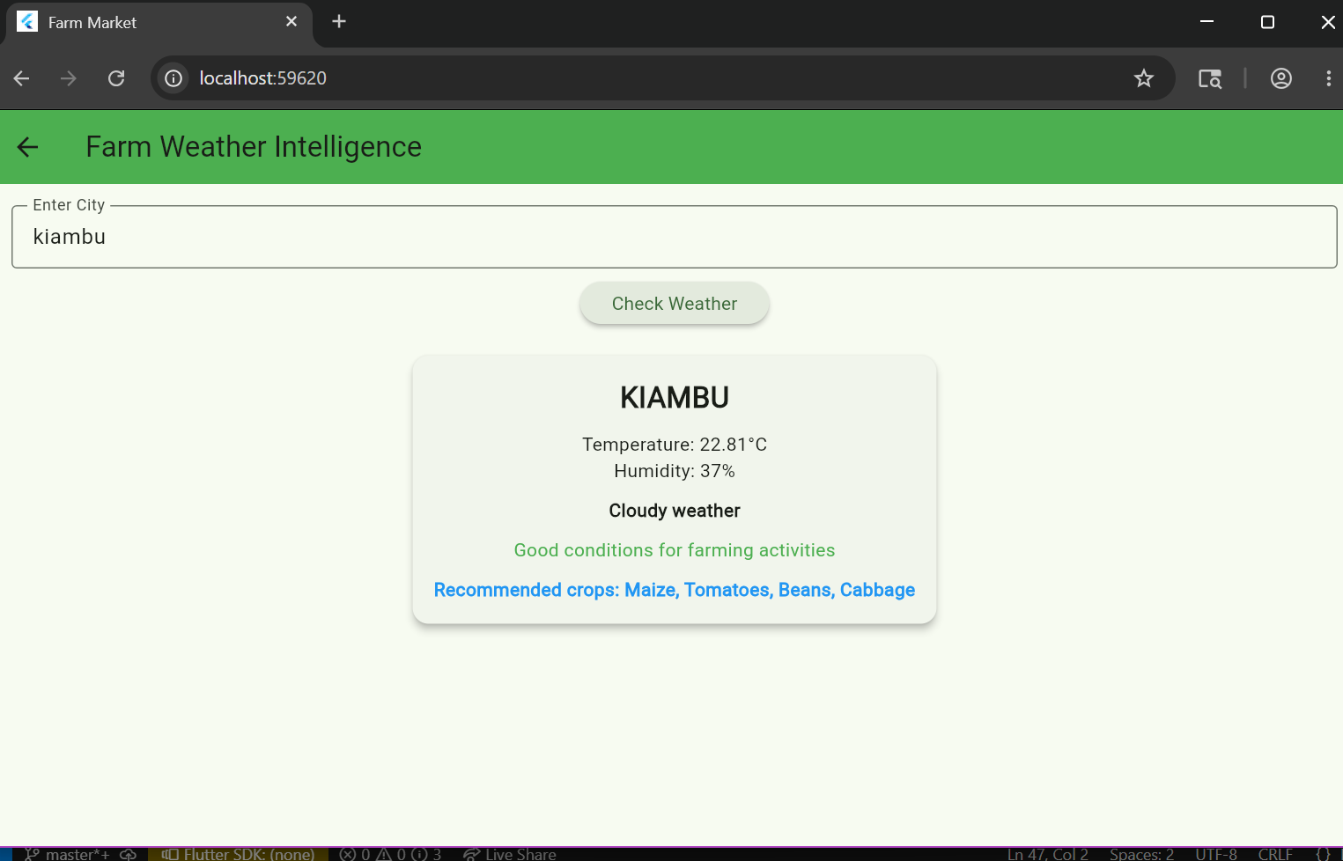
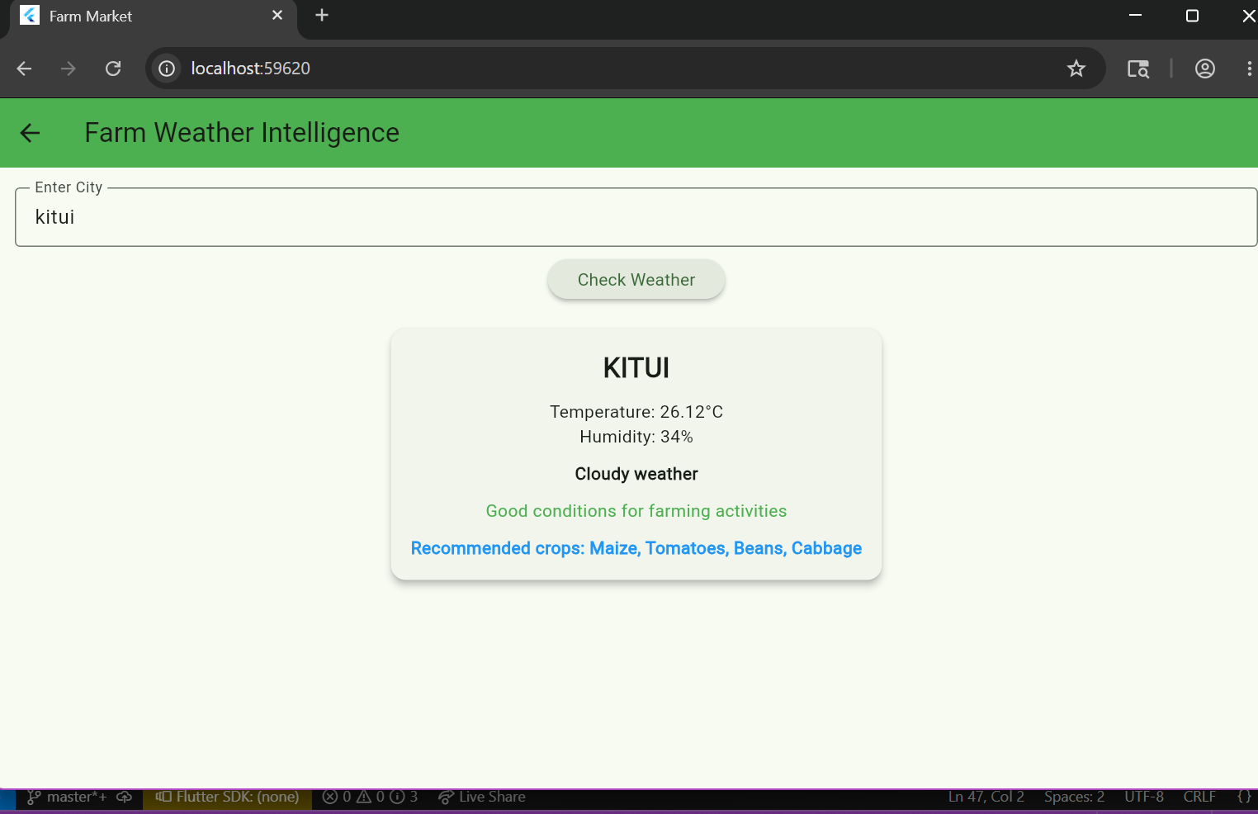
PERSONAL REFLECTON
Integrated a REST API using OpenWeatherMap API. Learned how to fetch and display live data and added crop recommendations based on weather conditions for smarter farming decisions.

Week 7: Project Planning Application Architecture

Personal reflection
Improved my understanding of application architecture, especially system structure and component interaction. I learned how frontend, backend, and data layers connect. I still need more practice in designing clear architecture diagrams and improving system planning skills.

Week 8: Project Planning

Week 9: Device Features and Sensors

Same as week 1

Week 10: Notifications and Background Services

Same as week 1

Week 11: Mobile Security

Same as week 1

Week 12: Testing and Debugging

Same as week 1

Week 13: Application Deployment

Same as week 1

Week 14: Final Project Presentation

Same as week 1

Semester Project Tracking

Project Title

Project Objectives

Project Requirements

Development Milestones

Testing Results

Lessons Learned

Future Improvements

End of Semester Reflection

Summary of Skills Acquired

Most Interesting Topic

Major Challenges Faced

How Challenges Were Overcome

Professional Growth Achieved

Overall Course Experience

Final Approval
Student Name: __________________________
Student Signature: ______________________
Date: _________________________________
Lecturer Name: _________________________
Lecturer Remarks: _____________________
Date: _________________________________

